IT 125-41194

Alex Arnold

4-21-25

Lab 13.1.10

Part 1: Connect to a Wireless Router

Step 1: Connect Admin to WR.

Step 2: Configure Admin to use DHCP.

**Step 3: Connect to the WR Web Interface.**

Step 4: Configure the Internet Port of WR.

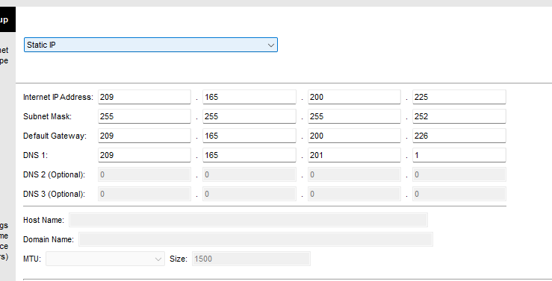

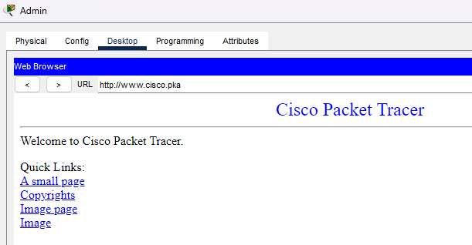

Settings verification

Part 2: Configure the Wireless Settings

Step 1: Configure the WR SSID.

Step 2: Configure wireless security settings.

Step 3: Connect the Wireless Clients.

Laptop 1

Laptop 2

Part 3: Connect Wireless Clients to an Access Point

Step 1: Configure the Access Point.

Step 2: Connect the Wireless Clients.

Laptop 3

Network map with all devices connected

Part 4: Other Administrative Tasks

Step 1: Change the WR Access Password.

Step 2: Change the DHCP address range in WR.

New ip for admin pc

Laptop 2 connection good

Laptop 3 connection good